**Description :**

The Aquamet 15mm Water Meter-Multi Jet is a water meter measuring up to 6,000 liter per hour. It features a stainless-steel housing with an electronic pulse motor and a precision magnetic drive that delivers constant flow rate. The device is ideal for commercial, industrial, and residential applications that require precise measurement of water flow, including water supply meters and industrial flow meters.

The meter displays water flow and temperature, the amount of water used, and other data that is useful when managing the amount of water being used. The Multi Jet is a dynamic meter that monitors the flow of water based on the pressure difference between its two outlets. This multi-jet technology provides reliable and efficient readings, even when there's a change in pressure or temperature.

This product is very durable and comes with an LED light which makes it easier to see where you are going while working on a water line. The LED light blinks when water is flowing through the meter and works very well in dark areas. It also comes with a nice carrying case which holds everything nicely.

It can read consumption at up to ten different points within the same line, which allows it to precisely measure consumption in apartments or houses with multiple users.

Buy Aquamet 15mm Water Meter-Multi Jet online in India at wholesale rates. If you have been looking for Aquamet 15mm Water Meter-Multi Jet dealers, your search ends here as you can get the best Aquamet 15mm Water Meter-Multi Jet distributors in top cities such as Delhi NCR, Mumbai, Chennai, Bengaluru, Kolkata, Chennai, Pune, Jaipur, Hyderabad and Ahmedabad. You can purchase Aquamet 15mm Water Meter-Multi Jet of the finest quality and rest assured to get the best in terms of both durability and performance. If you are bothered about the Aquamet 15mm Water Meter-Multi Jet prices, you can be totally sure to get the best rates as Industrybuying brings you genuine Aquamet 15mm Water Meter-Multi Jet rates and quality assured products only from the best of brands with exclusive brand discounts you won’t find anywhere else. Procure Aquamet 15mm Water Meter-Multi Jet today and avail the best offers on your purchase.

SKU: HYD.WAT.97644173

Size: 15mm

Material: Brass

Application: Domestic

Type of Product: Water Meter

Test Pressure: 2 Mpa

Country of Origin: India

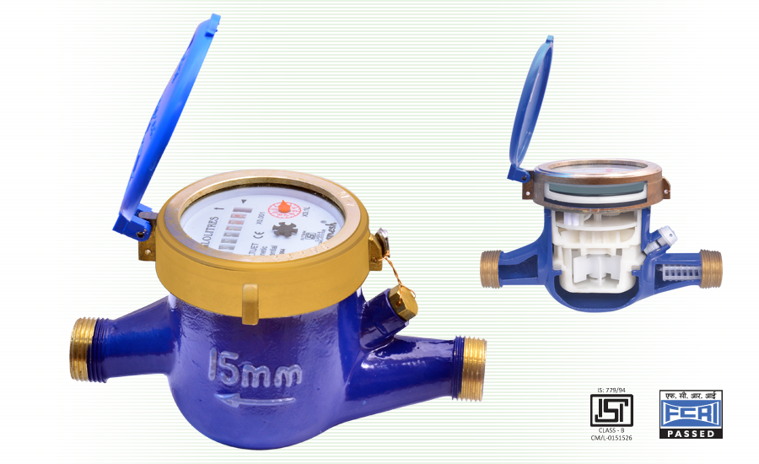

* Class-B in horizontal position, offering and outstanding performance with exceptional high accuracy.
* The magnetic counter is completely separated from water and always stays clean, even under adverse condition.
* Vaccum sealed register for clear reading.
* The impeller is the only part which comes in contact with water.
* Size range from 15mm to 50mm.

